EXP : 7 | COOKIE TO STORE USER INFORMATION

AIM:
Write a Servlet program to
store a user's preferences (like theme or language) using cookies. Retrieve and
display these preferences on subsequent visits.

CODE:

Cookie.html:
<!DOCTYPE html>
<html>
<head>
<meta charset="ISO-8859-1">
<title>Insert title here</title>
</head>
<body>
<form action="/janani/cookie" method="post">
<p>
<label>Username</label>
<input type=text name=username placeholder="Enter name"/><br><br>
</p>
<p>
<label>Password</label>
<input type=password name=password /><br><br>
<input type=submit value=Submit>
</p>
</form>
</body>
</html
Cookie.java:
package com.janani.servlet;

import java.io.IOException;
import javax.servlet.ServletException;
import javax.servlet.annotation.WebServlet;
import javax.servlet.http.Cookie;
import javax.servlet.http.HttpServlet;
import javax.servlet.http.HttpServletRequest;
import javax.servlet.http.HttpServletResponse;

/**
* Servlet implementation class cookie
*/
@WebServlet("/cookie")
public class cookie extends HttpServlet {
private static final long serialVersionUID = 1L;

/**
* @see HttpServlet#HttpServlet()
*/
public cookie() {
super();
// TODO Auto-generated constructor stub
}

/**
* @see HttpServlet#doGet(HttpServletRequest request, HttpServletResponse response)
*/
protected void doGet(HttpServletRequest request, HttpServletResponse response) throws ServletException, IOException {
// TODO Auto-generated method stub
response.getWriter().append("Served at: ").append(request.getContextPath());
}

/**
* @see HttpServlet#doPost(HttpServletRequest request, HttpServletResponse response)
*/
protected void doPost(HttpServletRequest request, HttpServletResponse response) throws ServletException, IOException {
String user = request.getParameter("username");
String pass = request.getParameter("password");
if(user.equals("123") && pass.equals("123") ){

Cookie username = new Cookie("username", user);
username.setMaxAge(60*60);
username.setPath("/");
response.addCookie(username);

response.sendRedirect(request.getContextPath() + "/getcookie");

}
}
}
GetCookie.java:
package com.janani.servlet;

import java.io.IOException;
import java.io.PrintWriter;

import javax.servlet.ServletException;
import javax.servlet.annotation.WebServlet;
import javax.servlet.http.Cookie;
import javax.servlet.http.HttpServlet;
import javax.servlet.http.HttpServletRequest;
import javax.servlet.http.HttpServletResponse;

/**
* Servlet implementation class getcookie
*/
@WebServlet("/getcookie")
public class getcookie extends HttpServlet {
private static final long serialVersionUID = 1L;
private static final PrintWriter NULL = null;

/**
* @see HttpServlet#HttpServlet()
*/
public getcookie() {
super();
// TODO Auto-generated constructor stub
}

/**
* @see HttpServlet#doGet(HttpServletRequest request, HttpServletResponse response)
*/
protected void doGet(HttpServletRequest request, HttpServletResponse response) throws ServletException, IOException {
Cookie[] cookies = request.getCookies();
String cookieName = "username";
if (cookies != null) {
for (Cookie cookie : cookies) {
if (cookieName.equals(cookie.getName())) {
System.out.println("username "+cookie.getName());
PrintWriter out = response.getWriter();
out.println(cookie.getValue());
}
}
}
}

/**
* @see HttpServlet#doPost(HttpServletRequest request, HttpServletResponse response)
*/
protected void doPost(HttpServletRequest request, HttpServletResponse response) throws ServletException, IOException {
// TODO Auto-generated method stub
doGet(request, response);
}

}

OUTPUT:

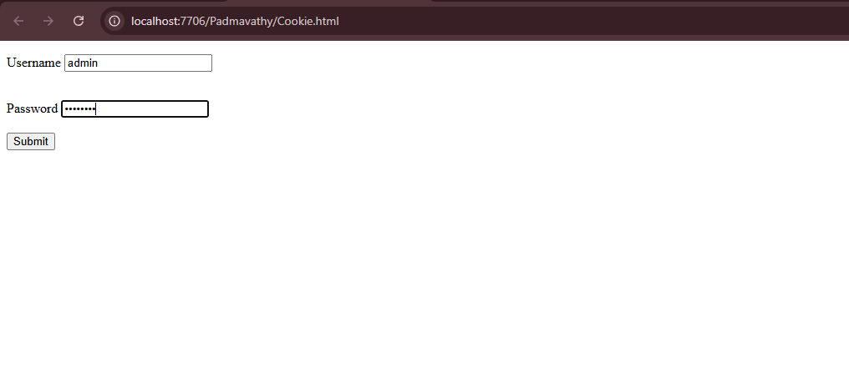

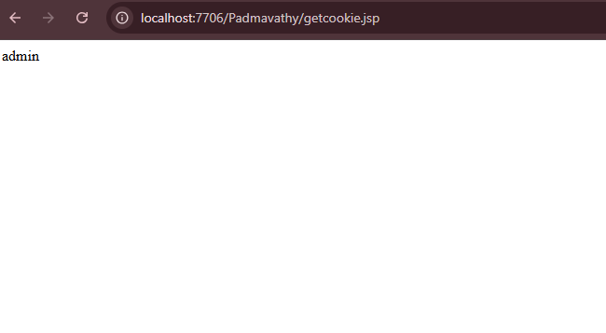

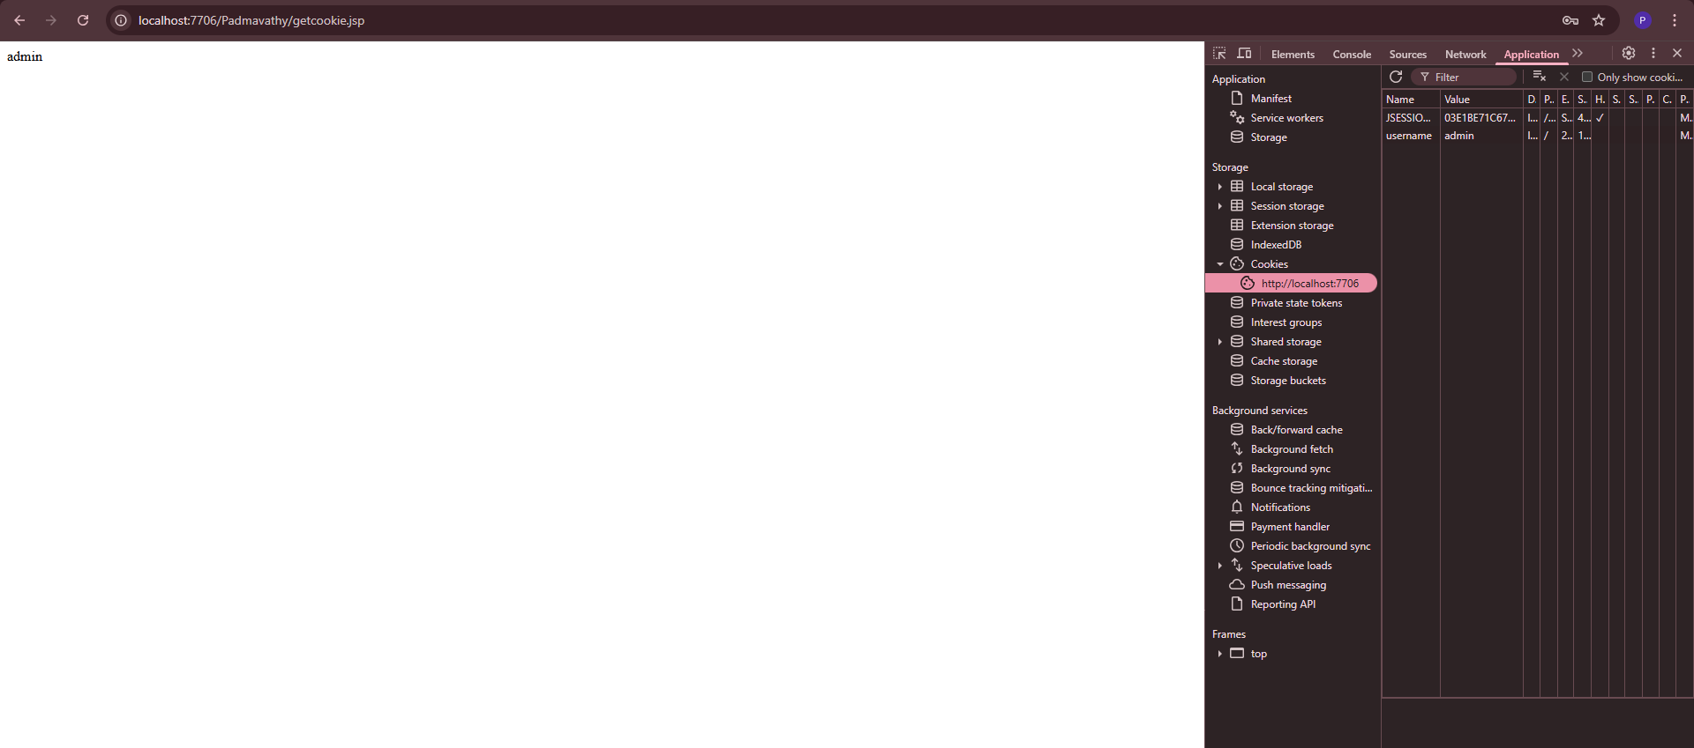

RESULT:
Handling user information using cookie is done using servlet successfully.

